

**Placement Empowerment Program**

***Cloud Computing and DevOps Centre***

Department : IT

**Name: Sanjay Raj S**

**Setting Up IAM Roles and Permissions**

**for a Virtual Machine**

# Introduction

Identity and Access Management (IAM) is a crucial aspect of cloud security that allows administrators to control who can access specific resources and what actions they can perform. By setting up IAM roles and permissions, you ensure that only authorized users or services can interact with your virtual machine (VM). This guide provides step-bystep instructions for creating an IAM role and assigning it to a VM on your cloud platform.

# Create an IAM Role

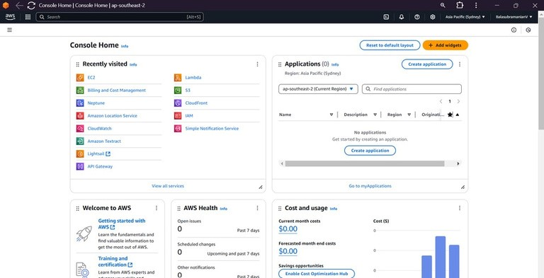

Log in to your cloud provider's console.

**Navigate to the IAM service.**

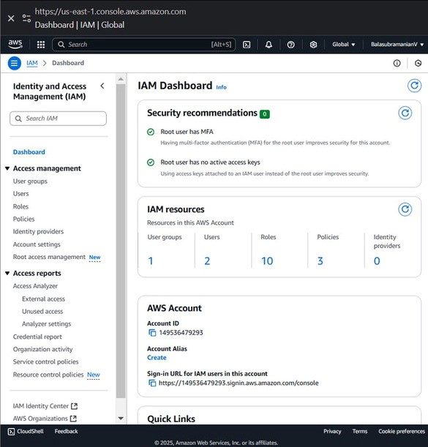

**Create a new role: Choose the service that will use this role (e.g., Compute Engine for Google Cloud or EC2 for AWS). Select the type of trusted entity (such as a service account or a specific user group). Steps are mentioned below**

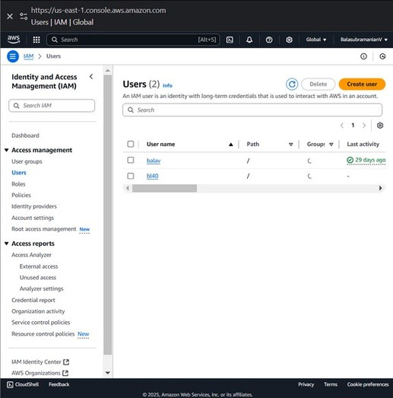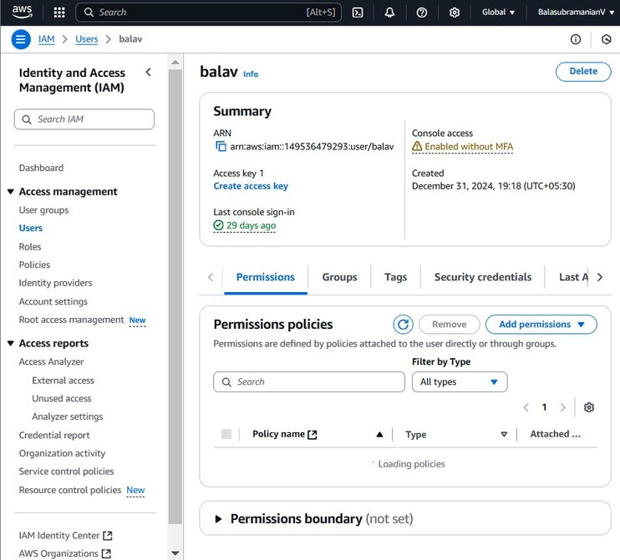

**Attach necessary permissions:**

**Assdefine allowed actions (e.g., read-gn policies that only access, full control, or specific API permissions).**

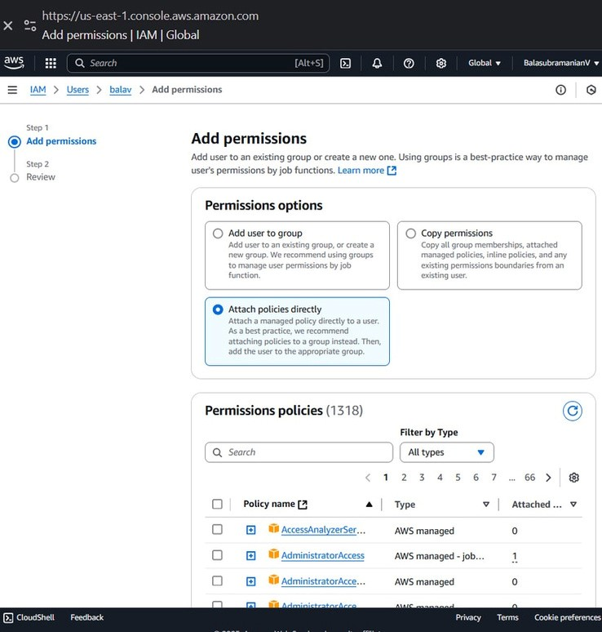

**Provide a meaningful name and description for the role.**

**Save the role.**

**Assign the Role to a Virtual Machine**

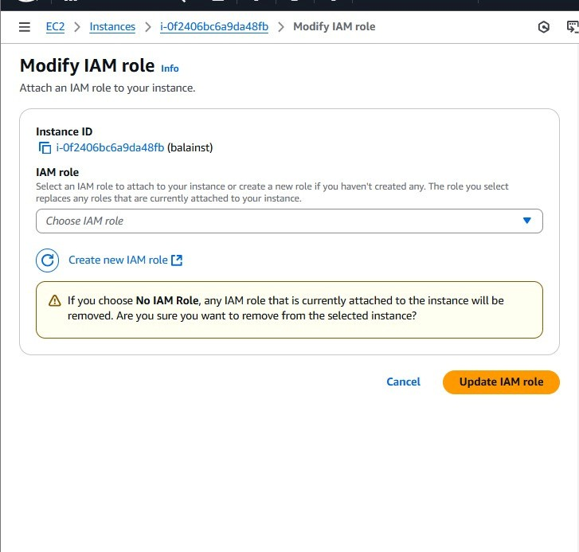

**Modify Instance IAM Role:**

**Select the EC2 instance you want to assign the IAM role to.**

**Click Actions > Security > Modify IAM Role.**

**Choose the IAM role created earlier from the dropdown.**

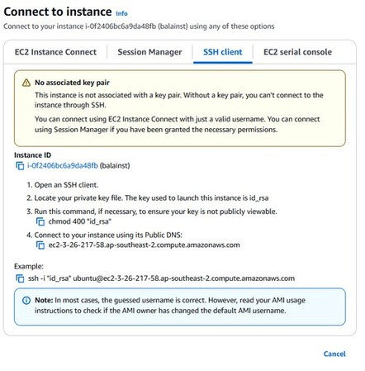 **Click Update IAM Role. 3. Verify IAM Role Permissions**

**Connect to the EC2 instance:**

**Use SSH or AWS Systems Manager Session Manager to access the instance.**

**Test Role Permissions:**

**Run AWS CLI commands to verify permissions.**

**Example: To check S3 access, run:**

**Ensure that restricted actions are blocked and allowed actions work as expected.**

**Check IAM Logs:**

**Navigate to AWS CloudTrail to monitor access logs and verify any unauthorized attempts.**

**Conclusion:**

**Setting up IAM roles and permissions for your EC2 instance ensures secure and controlled access to AWS resources. Regularly review and update permissions to align with security best practices.**

**By implementing IAM roles correctly, you reduce security risks and maintain a secure AWS environment.**